KARNATAK LAW SOCIETY'S


GOGTE INSTITUTE OF TECHNOLOGY

An Autonomous Institution under
Estd.: 1979
Estd. : 1939
Visvesvaraya Technological University, Belagavi

Activity Book

Interdisciplinary Project Work
(Activity-Based Learning)

Academic Year: 2025-26 Semester: 2

Student Name:
Anisha Mattikalli
Shivaraj B Samaji
Chidambar M. Navadagi
Ayan A Hudli

Branch: USN:
CSE/CV/ME/EC 2GI25CS021
2GI25CV082
2GI25ME026
2GI25EC028

Team Name and Strength: Team RapidResQ
Mentor / Faculty Member Name: Sundarmoorthy
Institute Name: KLS Gogte Institute of Technology

KARNATAK LAW SOCIETY'S


GOGTE INSTITUTE OF TECHNOLOGY

An Autonomous Institution under
Estd.: 1979
Estd. : 1939
Visvesvaraya Technological University, Belagavi

Table of Contents

Week | Module Title | Activity Title | Page No. | Remarks
1–3 | Orientation, Team Formation and Literature Survey | Communication & Team  Activities
4 -6 | Problem Statement,  Multiple Solution IDEAS Selection of Best IDEA | Review of Interviews/Interaction Problem Tree, Ideation
7–9 | Prototyping: Stage - 1 | Theory of Prototyping  Building, Design, Structure, Coding
9–12 | Prototyping: Stage - 2 | Development of physical  /working Prototyping, Testing and Analysis
13–14 | Review of Users, Refining and Pre-final Review | Review of Limitations/Challenges
15–16 | Final Demo & Social Pitch | Innovation Pitch

KARNATAK LAW SOCIETY'S


GOGTE INSTITUTE OF TECHNOLOGY

An Autonomous Institution under
Estd.: 1979
Estd. : 1939
Visvesvaraya Technological University, Belagavi

- Write about Interdisciplinary Project Work

RapidResQ is an AI-powered accident detection and emergency response coordination system. It integrates concepts from Computer Science, Electronics, Mechanical Engineering and Civil Engineering to automatically detect accidents, identify location through GPS, analyse severity and notify emergency services

- Brief about Literature Review

Existing emergency response systems mainly depend on manual reporting, causing delays. Recent studies on IoT, AI and GPS-based tracking show that automated detection can significantly reduce response time. RapidResQ combines these technologies into a unified platform

- Brief about Intellectual Property Rights (IPR)

The software design, dashboard interface and algorithms developed for RapidResQ are intellectual assets. Future development may include software copyright and patent protection for the integrated emergency workflow.

Week 1–3: Orientation & Team Formation (additional sheets may be attached, if required)
  - Activity Title: Problem Identification, Team Formation and Literature Survey for RapidResQ

  - Objective:
To identify an important social problem that can be solved using engineering concepts

  - Tasks Done:
Team formation and role allocation.
Brainstorming sessions.
Literature survey on road safety.
Discussion with peers and faculty.

  - Sketching and Problem Tree Analysis or Drawing:
The root cause identified was delayed emergency response after accidents. Lack of communication, absence of automated alert systems and delayed location sharing often result in the loss of the golden hour.

  - Faculty Signature with remarks

Week 4–6: Problem Statement, Multiple Solution IDEAS Selection of Best IDEA
  - Problem Statement:
Road accident victims frequently do not receive immediate medical assistance due to delays in reporting and coordination.

  - Key Observations:
Victims may become unconscious.
Emergency contacts are not informed automatically.
Ambulances lack real-time accident information.

  - Multiple Solution IDEAS:
- Smart Helmet Alert System.
- Emergency Mobile Application.
- Vehicle Sensor Network.
- AI-Powered Emergency Coordination Platform.

  - Photos / Sketches:
  - 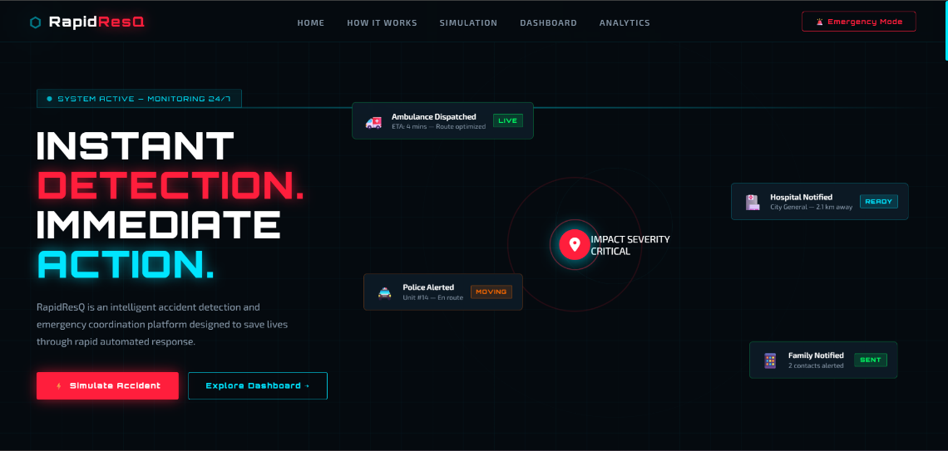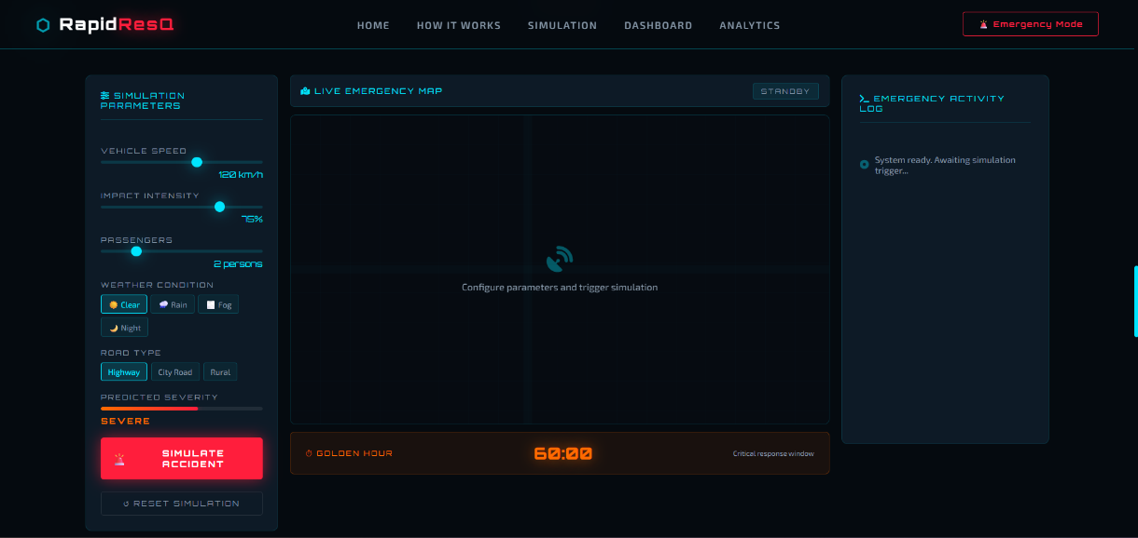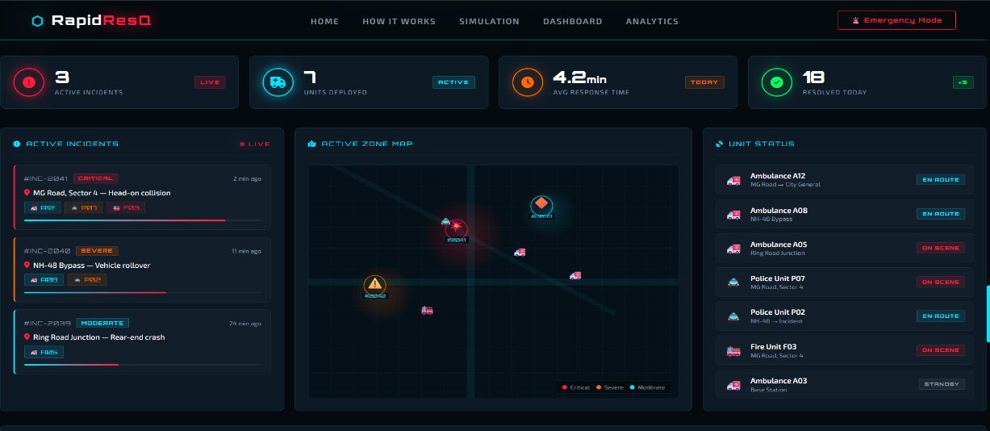

  - Challenges Noted:

  - Identifying the root causes behind delayed emergency response.
  - Comparing multiple solution ideas and selecting the most effective one.
  - Designing a solution that could work for both two-wheelers and four-wheelers.
  - Planning a system that integrates AI, GPS tracking, and emergency communication into a single platform.
  - Ensuring the proposed solution is practical, cost-effective, and easy to implement.

  - Faculty Feedback & Signature:

Week 7–9: Prototyping: Stage - 1
  - IDEA selected for Protype development:
RapidResQ – An AI-Powered Accident Detection and Emergency Response Coordination System
RapidResQ is an intelligent emergency management platform designed to reduce the time taken to provide medical assistance after road accidents. The prototype focuses on automatically detecting accidents, obtaining the victim's real-time GPS location, analysing the severity of the incident, and immediately notifying emergency services such as ambulances, hospitals, police departments, and the victim's family members.
The system is represented through an interactive web-based dashboard developed using HTML5, CSS3, JavaScript, and Font Awesome. The prototype also includes a simulation module where factors like vehicle speed, impact intensity, weather conditions, road type, and passenger count are used to demonstrate the working of the emergency response process.

  - Justification for Selection:

RapidResQ was selected for prototype development because it addresses the critical issue of delayed emergency response during road accidents. Unlike conventional systems that depend on manual reporting, RapidResQ automates the entire process by using AI-based accident detection and real-time GPS tracking.

The solution integrates multiple engineering disciplines and provides a practical, scalable, and user-friendly platform that can be enhanced in the future with IoT sensors and smart city infrastructure. Its potential to reduce response time and improve coordination between hospitals, ambulances, and police services makes it an effective and socially beneficial innovation.

  - Faculty Feedback & Signature:

Week 10–12: Prototyping: Stage - 2
  - Techniques/Platforms Used:
HTML5 – Used to create the basic structure and layout of the web application.
CSS3 – Used for designing the user interface, animations, and responsive dashboard elements.
JavaScript – Used to implement the core functionality, interactive features, and simulation logic of the system.
Font Awesome – Used to incorporate modern icons and improve the visual appearance of the dashboard.
AI-Based Simulation Technique – Used to simulate accident detection and severity analysis based on factors such as vehicle speed, impact intensity, weather conditions, road type, and passenger count.
GPS Tracking Simulation – Used to demonstrate real-time location identification and emergency coordination.
Dashboard Visualization – Interactive panels, live maps, status cards, and analytics charts were used to present emergency information effectively.
Modular Software Development Approach – The project was developed in independent modules such as accident detection, location tracking, severity analysis, emergency dispatch, and family notification, making the system scalable and easy to maintain.

  - Prototype Description:

The prototype developed for RapidResQ is a web-based simulation model designed to demonstrate an AI-powered accident detection and emergency response coordination system. The primary objective of the prototype is to show how technology can be used to reduce the time taken to provide assistance during road accidents.

The prototype consists of an interactive dashboard built using HTML5, CSS3, JavaScript, and Font Awesome. It simulates the complete emergency workflow, beginning with accident detection and ending with the dispatch of emergency services. The system analyses parameters such as vehicle speed, impact intensity, weather conditions, road type, and passenger count to determine the severity of the accident.
Once an accident is detected, the prototype automatically locks the GPS location of the incident and displays it on a live emergency map. Based on the severity analysis, it generates alerts and simulates the dispatch of ambulances, hospitals, and police units while also notifying the victim's family members. The dashboard provides real-time status updates, incident logs, emergency analytics, and response time monitoring.
The prototype also includes an Interactive Simulation Center, where different accident scenarios can be tested by changing the input variables. This helps in demonstrating the flexibility and practical application of the system under various conditions.

Although the current model is software-based, it has been designed with future scalability in mind. The system can later be integrated with IoT sensors, vehicle telematics, smart helmets, wearable devices, and 5G-enabled smart city infrastructure to create a fully automated real-world emergency response network.
Overall, the RapidResQ prototype successfully demonstrates the concept of intelligent accident management by combining AI, GPS tracking, and automated communication into a single, user-friendly platform aimed at saving lives through faster emergency response.

  - Photos of Prototype Model:

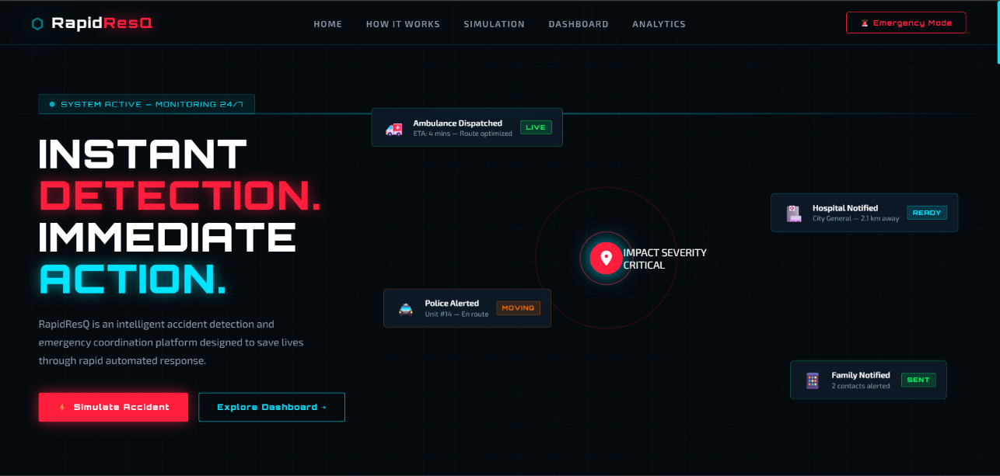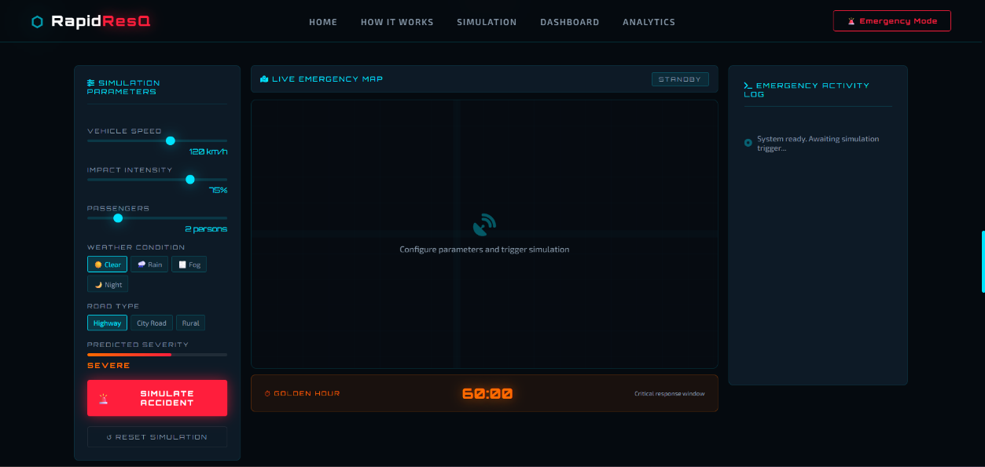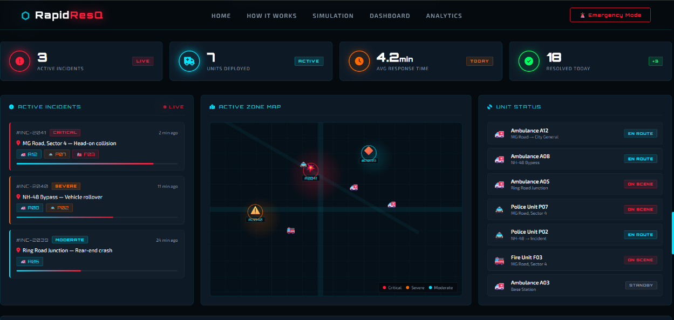

  - Faculty Feedback & Signature:

Week 13–14: Review of Users, Refining and Pre-final Review
  - User Testing Report:

  - Feedback Received (List out the important/crucial points):

  - Review:

  - Revisions Made:

  - Faculty Feedback & Signature:

Week 15–16: Final Demo & Pitch (for CIE finalization)
  - Project/Idea Title:
  - Team Members:

  - Targeted Problem:
  - Final Report of the Project: Attach Separately
  - Pitch Summary: Poster/PPT: Attach Separately

  - Jury Comments:

  - Marks (out of 50):

  - Faculty Signature:

Final Reflection & Self-Assessment (Student shall answer the following questions prior to final viva-voce or presentation)

  - What did I learn from this course?

  - Skills I gained:

  - Challenges I faced and overcame:

  - What would I do differently next time?

  - Faculty Suggestions:

